Supporting information:
- R&R are not in the framework/guidelines but in the MCF (we should see who the owner is)
  - MCF does not have roles and responsibilities defined; TOM has it on a high level (please see below). MCF is owned by 2LoD, and it is a document to link asset types to the control requirements (i.e., whether control requirements are relevant for different asset types).

Tasks:
- (1st) Progress of Boris 1LoD written rules … so far, we haven’t seen anything (today 0% procedure in in place and 0% in LE in place). IA appraisal is required if we can meet the 31.12. deadline for all DORA related 1LoD written rules (red/green).
> None-DORA related written rules may take time until end of 2026.
> Also, operationalization can take place until end 2026.
  - Please see extract from S3 2024-063_F01 CAP below for the agreed procedure update timeline:
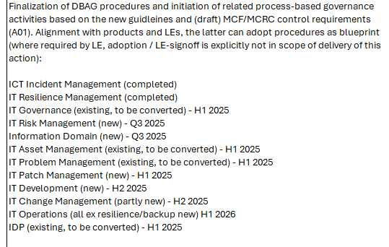
- Procedures are being published here: link. Around 20 procedures were already published (either updated or new ones), the process is happening according to agreed timeline above and sufficient progress was made.
- At the same time Group Security is also currently updating their procedures as was agreed in the DORA project and is according to the defined timeline. GS is working to streamline IS processes and enhance efficiency in line with the new framework. GS plans to subsequently formalize the IS operational documentation (procedures”) and fulfil control requirements to verify compliance. The DORA Program progress is tracked and monitored by appropriate oversight mechanisms, e.g. Steering Committees, Board presentations. Agreement in DORA Program is for keeping the yearly update cycle (or timelines required for AMELI) for GS related procedures. The 1LoD IS operational documents “procedures” (earlier called guidelines from 2023-24) are still valid until the (new) procedures are completed (in alignment to new framework) as per annual review cycle (due in Q3/Q4 2025). For more information please also see:
1LoD/2LoD delineation:
- R&R ... who is responsible for what (1LoD IT, IS-RM, IT-Gov [control gov?], IS assurance, IT Compliance, ...). Review of the new Target Operating Modell.
  - Please see the new model agreed between 1LoD and 2 LoD below:
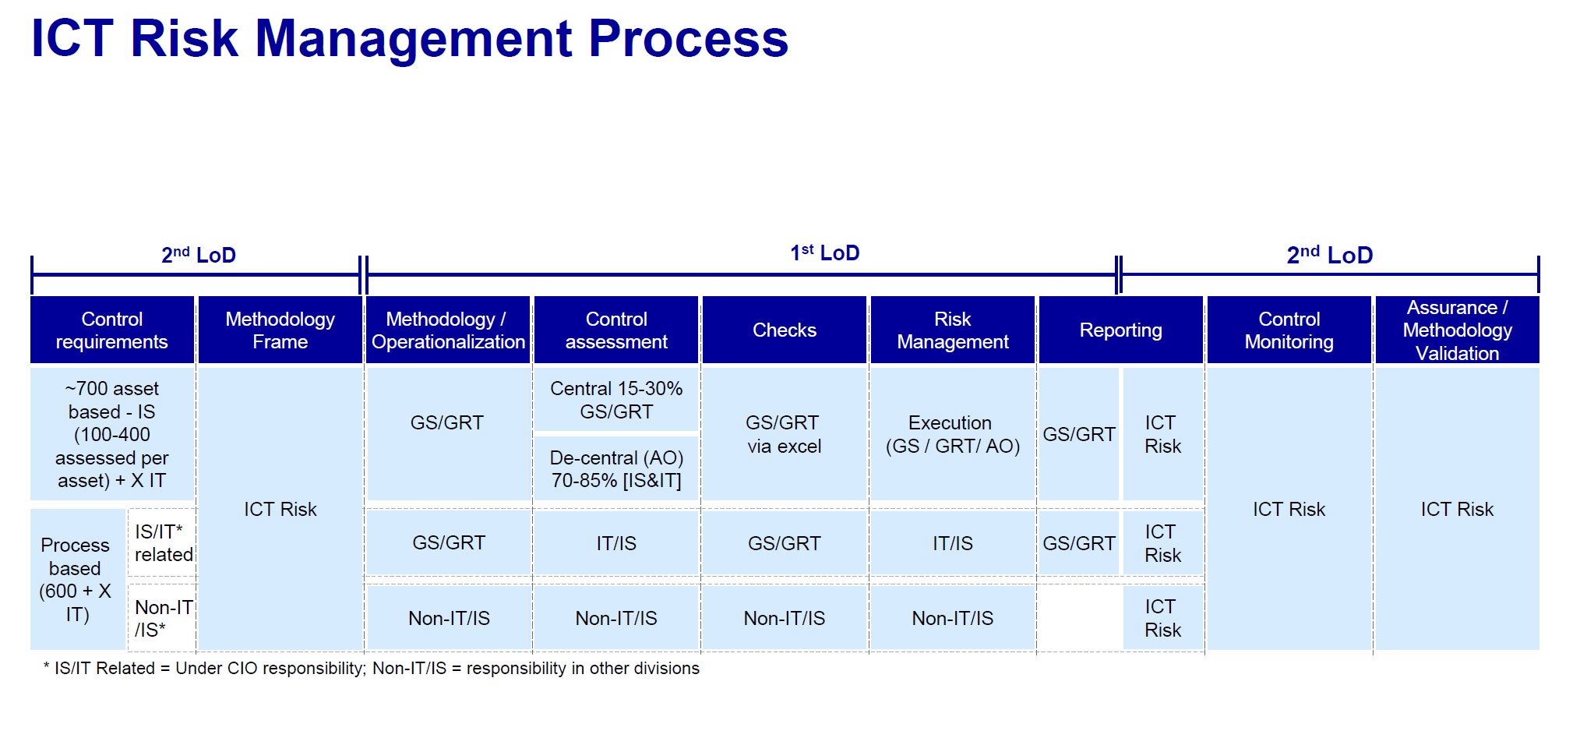
- 2LoD: Challenge written rules on completeness, appropriateness (granularity), particularly guidelines are mainly native DORA and do not consider DBG specific items such as:
c1) (bottom-up) Applications and components and containers
  - ICT Asset Management guideline (link) has Asset Matrix (Chapter 3.3) which defines different types of assets, including applications and containers.
c2) (bottom-up) Cryptographic policies, guidelines and procedures => 1LoD / 2LoD status;
either the old outdated or new written rules should be in place.
  - Encryption and Key Management Guideline is available from 2 LoD: link
  - In addition, encryption is covered in GS guideline: link. Please also see information above with regards to validity of GS documents.
c3) considering best practice (which on); requirement form 1LoD
  - 2LoD documentation includes several regulations and best practices/standards (e.g., DORA, ISO standards etc.)
  - New procedures from 1LoD cross-reference guidelines and requirements mentioned in them

c4) scope: for all LE, weakest link principle
  - As part of S3 2024-063_F01 CAP 2LoD should distribute the new framework to different legal entities for their consideration, next steps (i.e., framework implementation) are under responsibilities of LE CISOs.
  - Additionally, 1LoD procedures are also distributed to all LEs and considered by them to be adapted (Sharepoint with Written Rules has information on which legal entities adapted the procedures)
c5) Is the risk appetite sufficiently defined such as timeframe for critical vulnerability fixing?
  - Timeframe for vulnerabilities is defined in ICT Patch and Vulnerability Management Guideline (link)
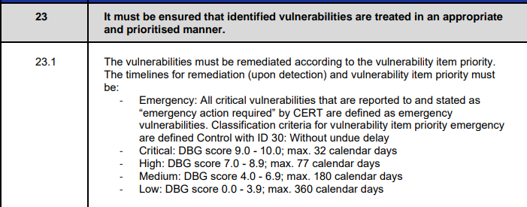

- Monitoring and Metrics:
d1) The DSC provides information to IT heads such as patching of vulnerabilities.
> Do we have proper escalation for exceptional numbers or long incompliances (several months overdue)?
> Do we define the path to green?
  - Please see screenshot from DCS KPIs reporting with the next steps defined.
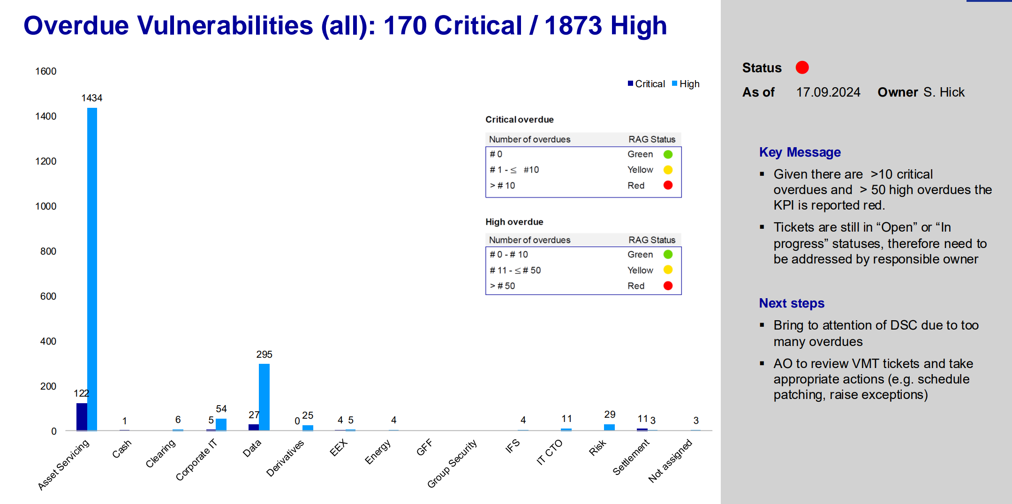

Audit proceeding:
- Once we have an audit opinion on this, we will determine if this topic might be the subject of the Cyber Conclusion, as findings or as appendix.
  - According to review performed and as agreed during the meeting on 31st of July with AB, TJT and DH topic is closed. No additional overarching finding will be raised as the outstanding aspects are fully covered by S3 finding 2024-063_F01. Progress of finding implementation was reviewed and assessed as satisfactory – 20 procedures already created by 1LoD, aligned and cross-referenced with 2LoD guidelines. On this basis, IA will be able to assess coherence, consistency and sufficiency of these internal requirements in detail in the course of future regular IT audits.

